TEAM GROUP: Raoul, Joao and Donatella

SUBJECT: Damped harmonic Oscillations

SUMMARY:

1. Physics Part: run an experiment
   1. Use for example ranger
2. Get/Analyze data with a handheld
3. Math Part: find a math model
4. Conclusion/Interpretation of physical constants

1.

Spring experiment with a body hung

A Ranger sensor is underneath a body of at least 5 cm of diameter

Make an initial spring stretching and measure the initial distance from the rest position (we’ll call it “amplitude”)

You leave the body and it will start oscillating up and down while the ultrasonic sensor will be recording the position data. Let the body find again its rest position and stop the data collection

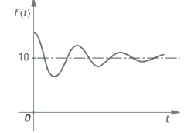

2.

Visualize the data plot and get information about the oscillation time by the difference between two consecutive maxima.

Select from the data table the points of maxima and make a separate plot of them.

The new plot shows decreasing behavior in time and apply a regression fit with an exponential function.

Save the constant at the exponent and call it **τ**

**3.**

Given the following model:

$$f\left(t\right)=Acos\left(ωt+φ\right)+c$$

$$A\left(t\right)=A_{0}e^{-\frac{t}{τ}}$$

Calculates the values of the parameters of the models

4.

Identify the angular frequency, the damping time constant and the oscillation amplitude

1. Second derivative…